How to publish your tender​
​

Tenders for public contracts that fall under EU rules must be published in the Tenders Electronic Daily (TED) portal. Public authorities may also choose to publish notices on the TED portal when a contract is of lower value. In TED the basic information for tenders is available in all official EU languages. ​
(In The Netherlands, you can publish on the Dutch portal, TenderNed, and it will automatically publish the information on TED as well).​
​

Requirements for European tenders to publish on TED:​
- All tender documents, and if applicable, prior information notice;​
- The results of the award​
- Changes in the procedure or in the contract;​
- The result of the procedure

The European tender timeline

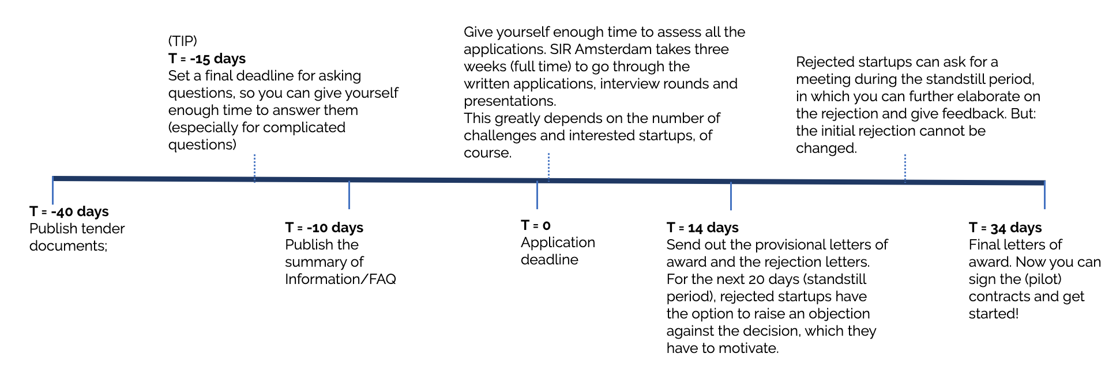

Tips for the Summary of Information (=Nota van inlichtingen)​

- The FAQ period, in which startups can ask questions about the programme and challenges, is not just for clarification, but also for correcting possible mistakes or contradictions. Encourage the startups to ask questions about the tender, because it will help you get a better sense of what they’re interested in, and it allows for small changes to improve the tender.​
- Don’t wait until the final deadline to answer all the questions, try and answer questions on time, so you can publish them already. Hopefully, this will prevent startups from asking the same questions, and it provides an opportunity to clarify the answers.​
- Organise a (digital) information meeting, so you can answer questions directly. Make sure you write the questions and answers down, so you can share these before the final deadline as well.

For the Dutch speakers – handy translations

